NACi Foodservice Scholarship MOWA
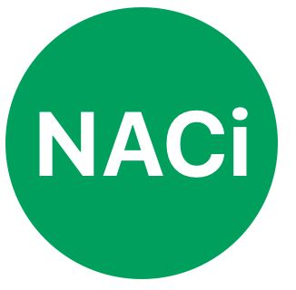
In partnership with Meal on Wheels Australia (MOWA),
the Nutrition and Catering Institute is excited to launch a scholarship program
supporting Meals on Wheels foodservice workers.
The scholarship includes:
Full registration to Meals on Wheels National Conference (including social events) valued at $715 Per scholarship
Total of 4 scholarships will be awarded for the 2022 national conference

Application close Friday December 10th 5pm EST

About the conference
Theme : ‘Re-connecting’
Start Date : Wednesday 23 March 2022 (sessions start 1:00pm)
End Date : Friday 25 March (2:00pm)
Venue : Stamford Plaza Brisbane
Contact: Kate Thiele (Managing Director MoWA) Kerrie Wise (Event Manager)
Website : www.mealsonwheels.org.au to view program (program available from 28 October when the conference registration is launched)
Every second year the MOWA runs a national conference to bring together delegates from service all over Australia to come together to network and share ideas.

Registration
All scholarship holders will have to register for the conference through the registration portal. This link will be provided to successful scholarship winners.
Travel arrangements
Travel arrangements are made by the scholarship holder and are not included in the scholarship.

Eligibility criteria
All service Members are eligible to apply for the scholarship.

Maximum of 4 total scholarships will be awarded and is open to all states.

All applicants will be notified once the selection process has been completed.
The decision of the scholarship panel is final.

Expectations of recipients of scholarship holder

Successful scholarship holders must provide

- A written blog post (300-400 words) with photo on conference experience and what was learned (written 24 hours post conference) for NACi and MOWA/MOWQ.
- Attend the social event to be introduced as a winner of the NACi Foodservice Scholarship MOWA
- Have photos taken with both NACi and MOWA representatives during the conference
- Provide a short testimony on the benefits of the NACi Scholarship program to be used on NACi & MOWA (written 5 days post conference)

Scholarship holders must attend all three days of the conference.

In unforeseen circumstances the recipient cannot attend the conference the scholarship holder will be required to reimburse total scholarship package back to the Nutrition and Catering Institute.

If the recipient cannot take up the scholarship, they are required to contact Dr Karen Abbey (0417 608 206) 48 hours prior as we will have a reserve scholarship list and the scholarship will be awarded to another person. Failure to inform and nonattendance the full scholarship amount must be reimbursed to the Nutrition and Catering Institute.

Closing date and time

Application close Friday December 10th 5pm EST

Any Questions please contact Dr Karen Abbey karen@nutcat.com.au 0417 608 206

Applications are to be email to info@nacinstitute.com.au

Application Criteria

Please complete the criteria below and email info@nacinstitute.com.au . If the application is incomplete, it will not be considered.

Name -

Position -

MOW Service -

Suburb/Town -

Email address -

In 50 words or less explain how attending the MOWA National Conference will support your foodservice skill development.

I have read the above information and understand the conditions and expectation in which this scholarship is being awarded.

Signature of scholarship applicant :

Date :

Applications are to be email to info@nacinstitute.com.au
Application close 5pm Friday 10th December 2021 EST

Date and time application received by the NACi office -

